S3 Task
Task: 1.Create an S3 bucket and upload some objects to S3.
Objective:
To create an Amazon S3 bucket and upload files (objects) to the bucket using the AWS Management Console.

Prerequisites
- AWS account with an IAM user having AmazonS3FullAccess or equivalent permissions.
- Internet connection.
- Files available on your local computer for upload (e.g., .txt, .jpg, .pdf).

Step 1: Sign in to AWS Management Console
- Open a web browser.
- Navigate to the AWS Management Console.
- Sign in using your AWS account or IAM user credentials.
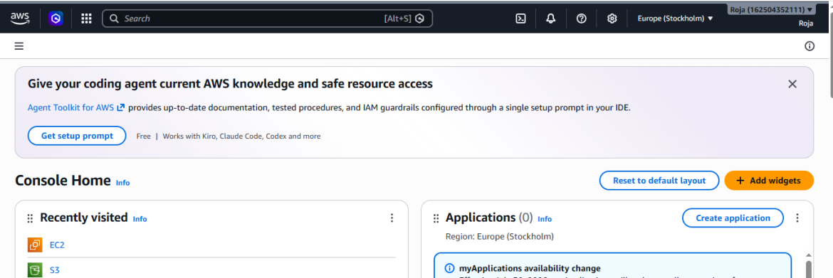

Step 2: Open the Amazon S3 Service
- In the AWS Console search bar, type S3.
- Click S3 from the list of AWS services.
- The Amazon S3 dashboard will open.
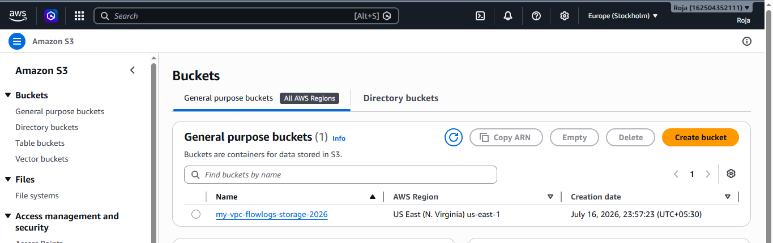

Step 3: Create an S3 Bucket
- Click Create bucket.
- Enter a globally unique bucket name.
  - Example:
student-swetha-bucket-2026
- Select the AWS Region.
  - Example:
Europe (Stockholm) eu-north-1
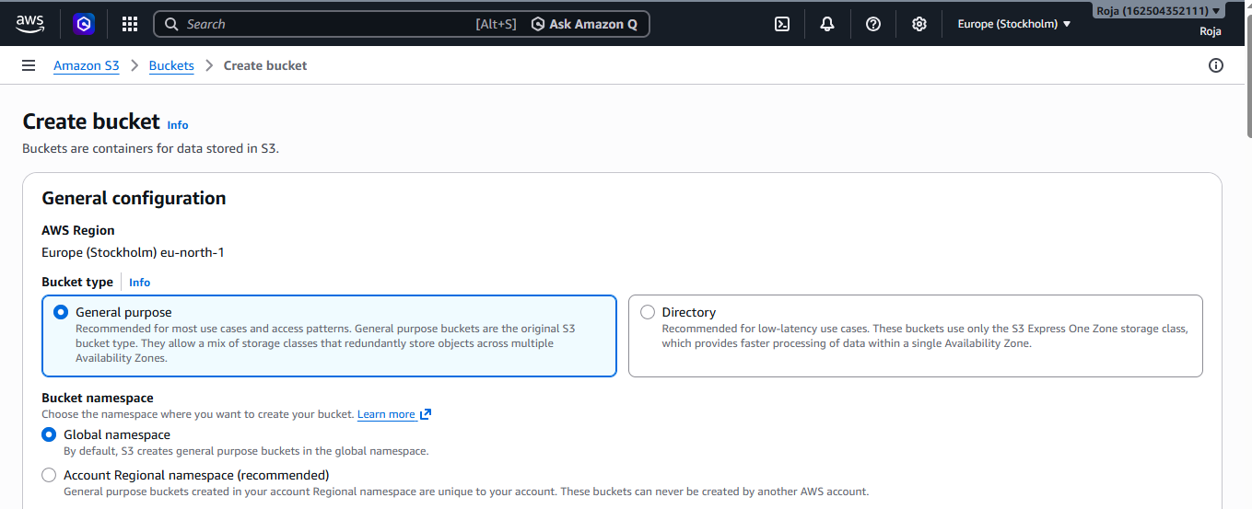
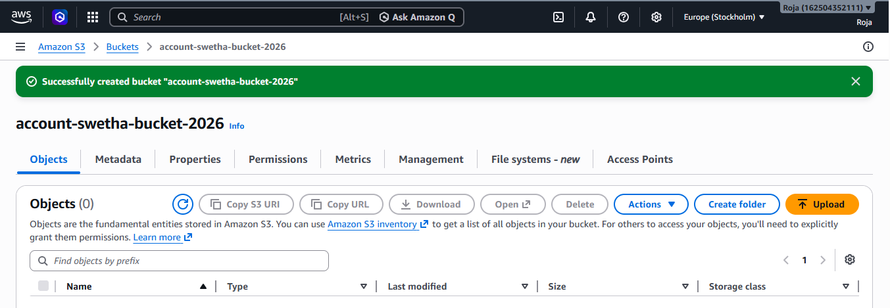

Step 4: Open the Bucket
- Click the name of the newly created bucket.
- The bucket will open to the Objects tab.
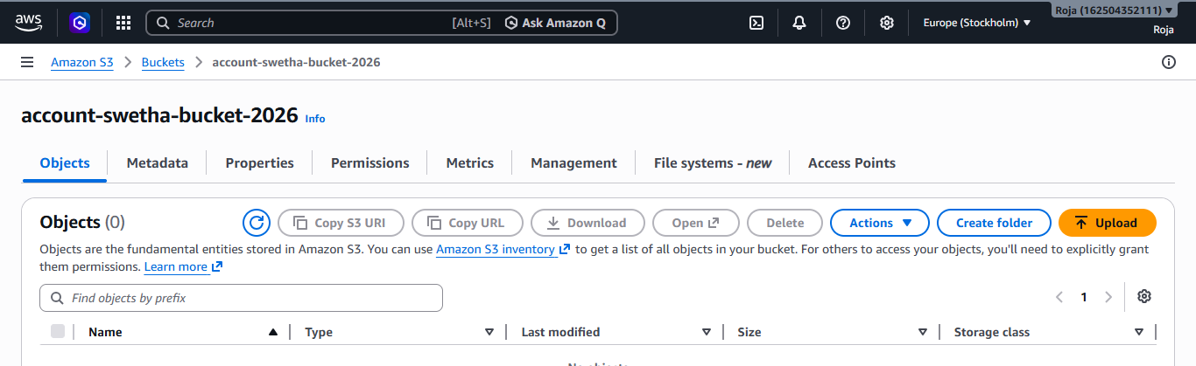

Step 5: Upload Objects to the Bucket
- Click Upload.
- Click Add file.
- Browse your local computer and select one or more files.
- Click Open.
- Verify the selected files appear in the upload list.
- Leave the default upload options unchanged.
- Click Upload.
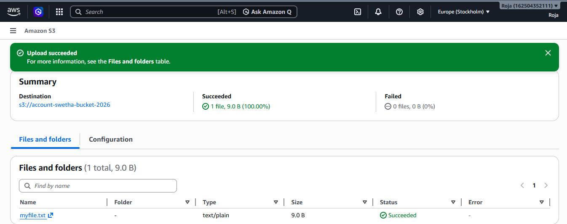

Step 6: Verify Uploaded Objects
- Return to the Objects tab.
- Confirm that all uploaded files are listed.
- Verify details such as:
  - Object name
  - Size
  - Last modified date
  - Storage class (Standard)
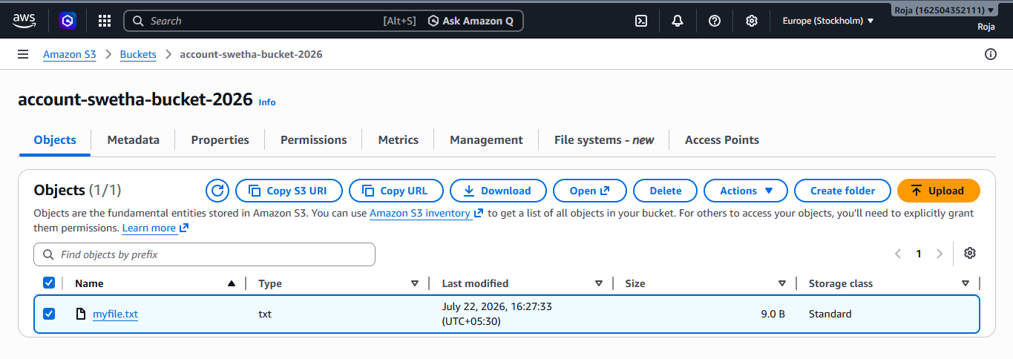
Step 7: Download an Object (Verification)
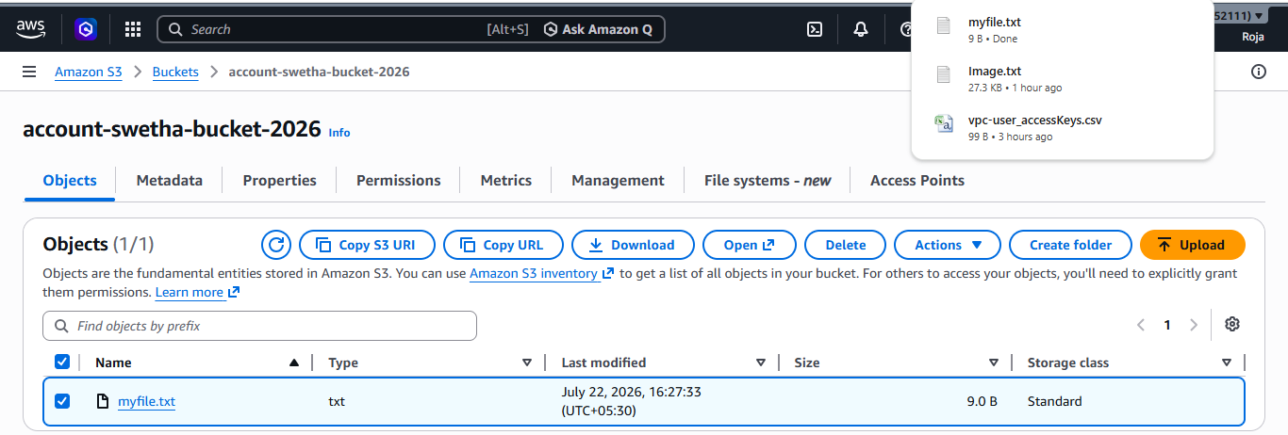

Task: 2. Deploy a static website in the S3 bucket.

Objective:
To host and deploy a static website using an Amazon S3 bucket.

Prerequisites
- AWS account with an IAM user having AmazonS3FullAccess or equivalent permissions.
- AWS Management Console access.
- Basic HTML files for the website (e.g., index.html, error.html).
- An existing S3 bucket or permission to create one.

Step 1: Open the Amazon S3 Service
- In the AWS Console search bar, type S3.
- Click S3 from the list of AWS services.
- The Amazon S3 dashboard will open.

Step 2: Create an S3 Bucket
- Click Create bucket.
- Enter a globally unique bucket name.
  - Example: account-static-bucket-2026
- Under Object Ownership, leave ACLs disabled (recommended).
- Under Block Public Access settings, uncheck Block all public access.
- Read the warning and acknowledge it by selecting the confirmation checkbox.
- Leave the remaining settings as default.
- Click Create bucket.
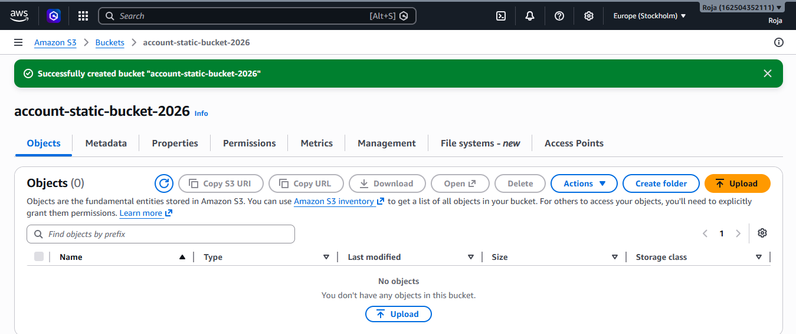

Step 3: Upload Website Files
- Open the newly created bucket.
- Select the Objects tab.
- Click Upload.
- Click Add files.
- Select the website files:
  - index.html
  - error.html
  - CSS, JavaScript, images (if any)
- Click Upload.
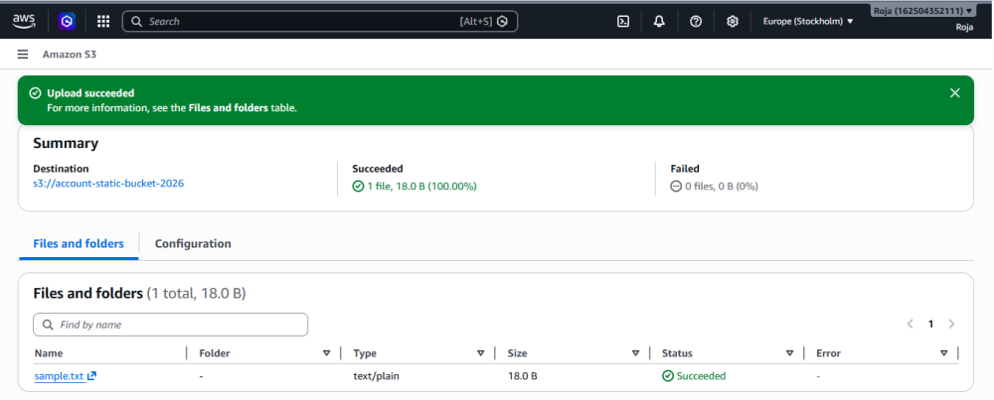

Step 4: Enable Static Website Hosting
- Open the bucket.
- Select the Properties tab.
- Scroll down to Static website hosting.
- Click Edit.
- Choose Enable.
- Select Host a static website.
- Enter:
  - Index document: index.html
  - Error document: error.html
- Click Save changes.
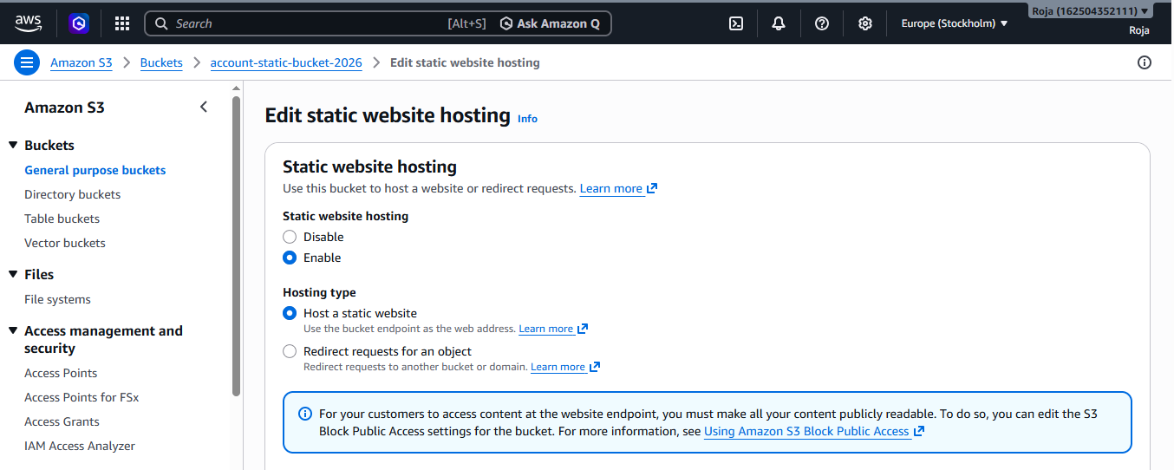
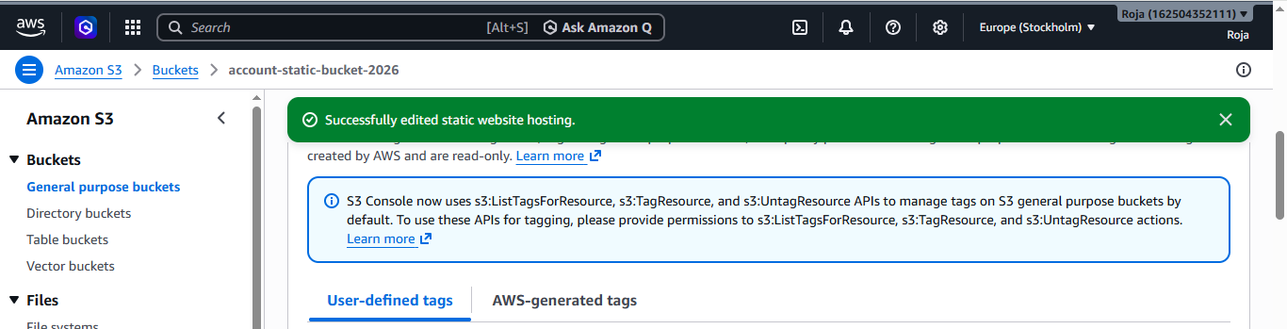
Step 5: Grant Public Read Access
- Open the bucket.
- Select the Permissions tab.
- Scroll to Bucket Policy.
- Click Edit.
- Paste the bucket policy
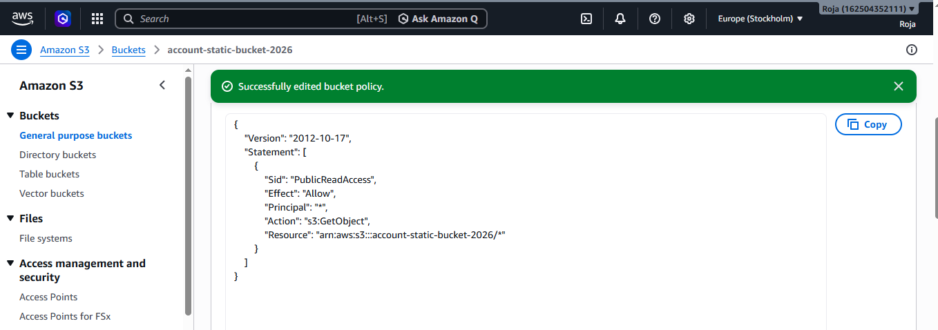

Step 6: Verify Object Permissions
- Open the Objects tab.
- Ensure the uploaded files are present.
- Verify they are accessible through the bucket policy.
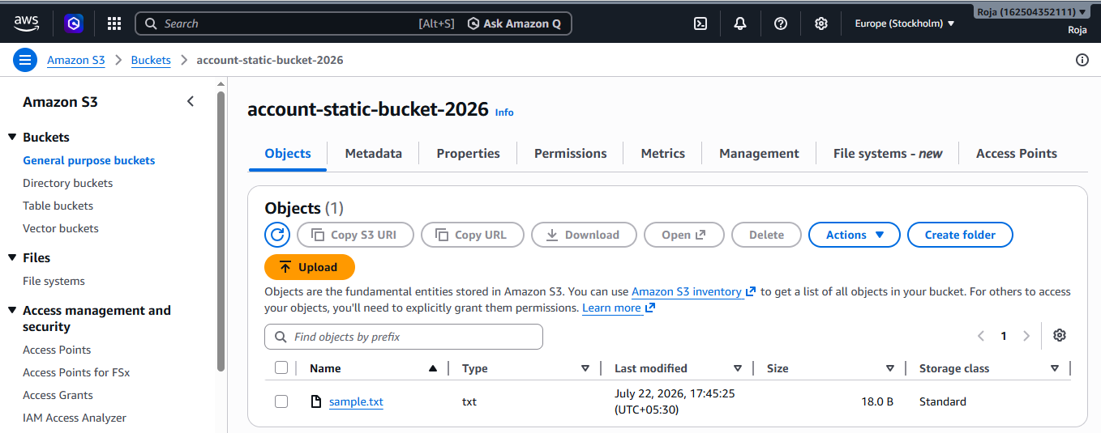

Step 7: Access the Static Website
- Go to the Properties tab.
- Scroll to Static website hosting.
- Copy the Bucket website endpoint URL.
- Open the URL in a web browser.
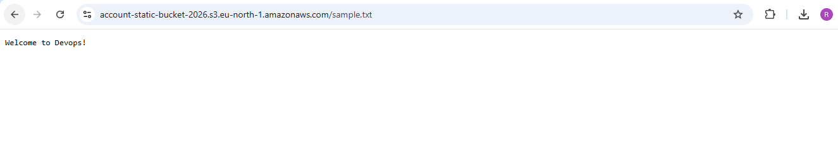
Task: 3. Enable cross-region replication on S3 buckets.
Objective:
To configure Cross-Region Replication (CRR) between two Amazon S3 buckets located in different AWS Regions.

Prerequisites
- AWS account with an IAM user having AmazonS3FullAccess or equivalent permissions.
- AWS Management Console access.
- Two S3 buckets created in different AWS Regions.
- Bucket Versioning must be enabled on both buckets.
- IAM permissions to create or use replication roles.

Step 1: Create the Source Bucket
- Open the Amazon S3 service.
- Click Create bucket.
- Enter a globally unique bucket name.
  - Example: aacount-static-bucket-2026
- Select the AWS Region : eu-north-1
- Leave the remaining settings as default.
- Click Create bucket.

Step 2: Create the Destination Bucket
- Click Create bucket again.
- Enter another globally unique bucket name.
  - Example: student-destination-bucket-2026
- Select a different AWS Region.
  - Example: us-east-1
- Leave the remaining settings as default.
- Click Create bucket.
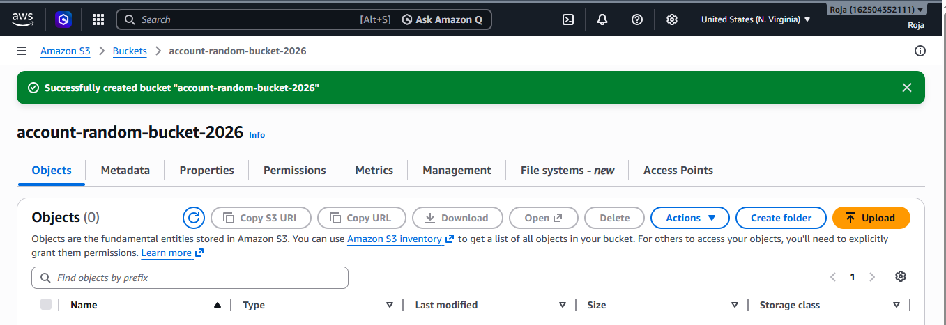

Step 3: Enable Versioning on the Source Bucket
- Open the source bucket.
- Go to the Properties tab.
- Scroll to Bucket Versioning.
- Click Edit.
- Select Enable.
- Click Save changes.

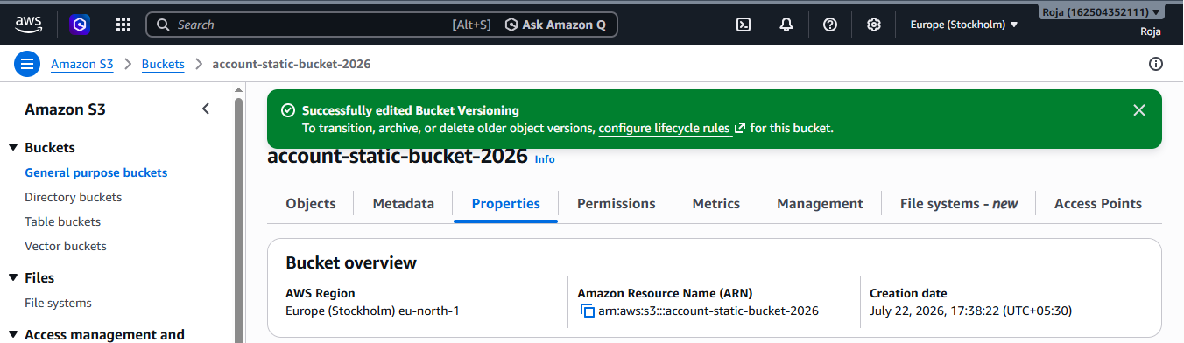

Step 4: Enable Versioning on the Destination Bucket
- Open the destination bucket.
- Go to the Properties tab.
- Scroll to Bucket Versioning.
- Click Edit.
- Select Enable.
- Click Save changes.
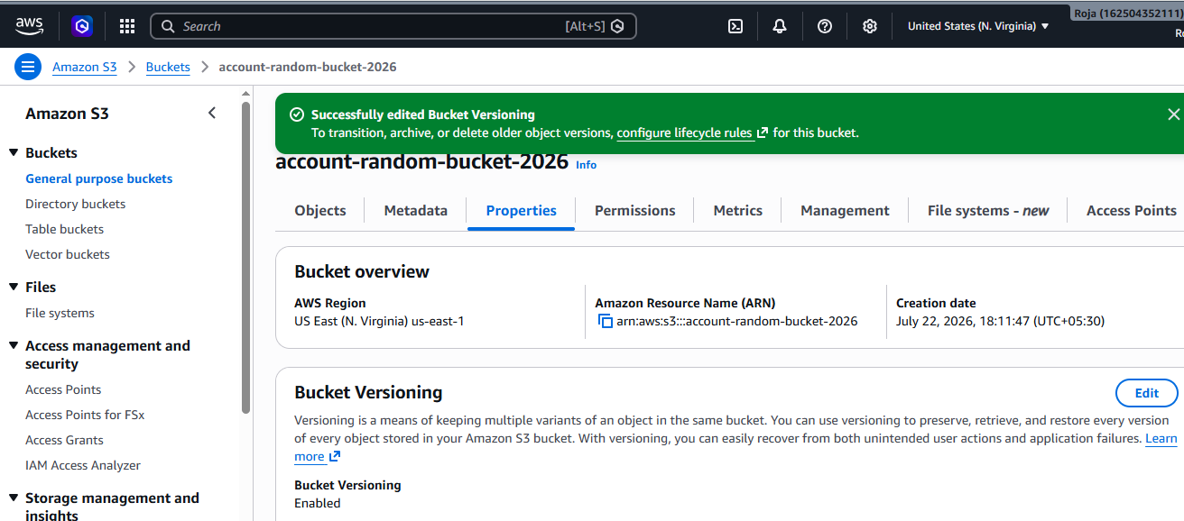

Step 5: Configure Cross-Region Replication
- Open the source bucket.
- Go to the Management tab.
- Scroll to Replication rules.
- Click Create replication rule.
- Enter a rule name.
  - Example:
    - CRR-Rule

- Select Apply to all objects in the bucket.
- Under Destination, choose:
- Specify a bucket in this account
- Select the destination bucket.
- Choose Change object ownership to destination bucket owner (if required).
- Under IAM Role, select:
- Create new role (recommended)
- Leave the remaining options as default.
- Click Save.
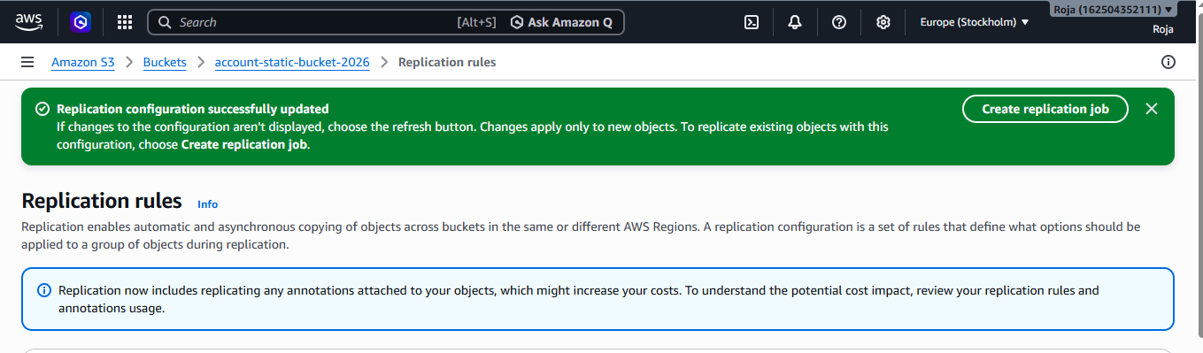
Step 6: Upload an Object to the Source Bucket
- Open the source bucket.
- Go to the Objects tab.
- Click Upload.
- Select a file from your local computer.
- Example:
  - doc.txt
- Click Upload.
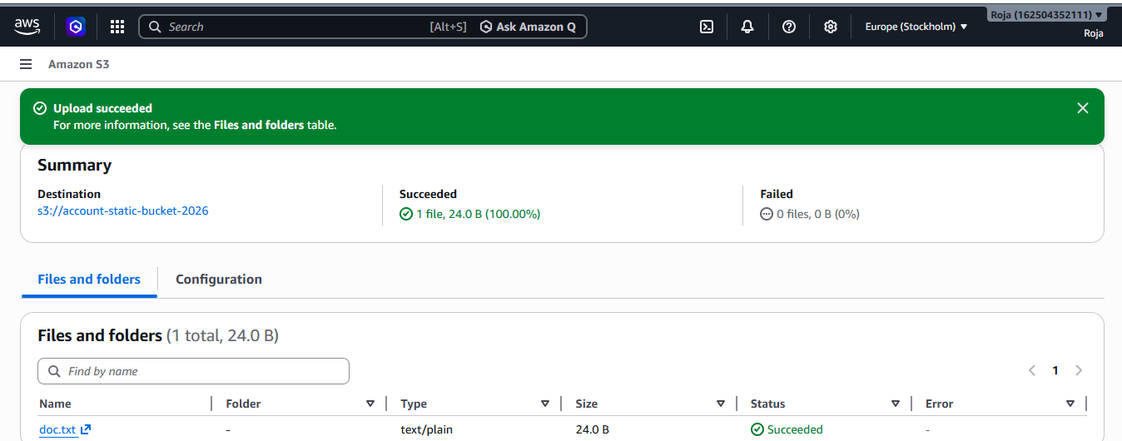

Step 7: Verify Replication
- Wait for a few moments.
- Open the destination bucket.
- Select the Objects tab.
- Verify that the uploaded object appears in the destination bucket.
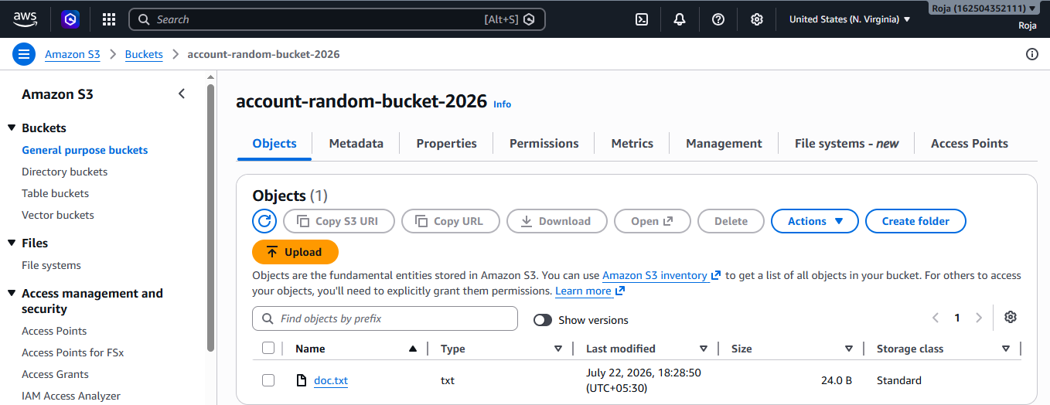

Task: 4. Configure a bucket policy so only the Admin user can see the objects of the S3 bucket.
Objective:
To configure an Amazon S3 bucket policy that allows only the Admin IAM user to view the objects stored in an S3 bucket.

Prerequisites
- AWS account with IAM access.
- An IAM user named Admin.
- An existing Amazon S3 bucket.
- IAM permissions to create and modify S3 bucket policies.
- At least one object uploaded to the S3 bucket.

Step 1: Open the Amazon S3 Service
- Create an s3 bucket
- Upload objects to the bucket
Step 2: Obtain the Admin User ARN
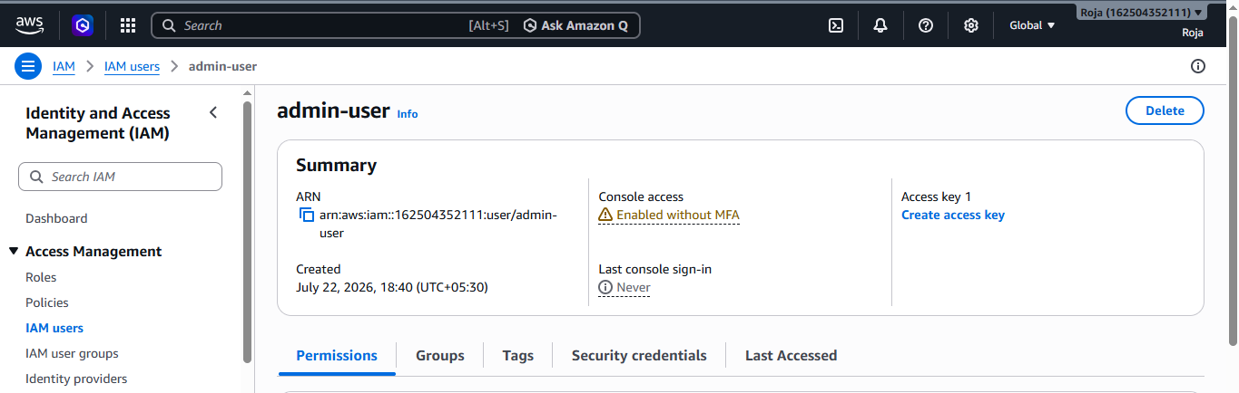

Step 3: Configure the Bucket Policy
- Return to the Amazon S3 service.
- Open the required bucket.
- Select the Permissions tab.
- Scroll down to Bucket Policy.
- Click Edit.
- Replace the placeholders (YOUR-BUCKET-NAME and YOUR-ACCOUNT-ID) with your actual bucket name and AWS account ID, then paste the following policy:
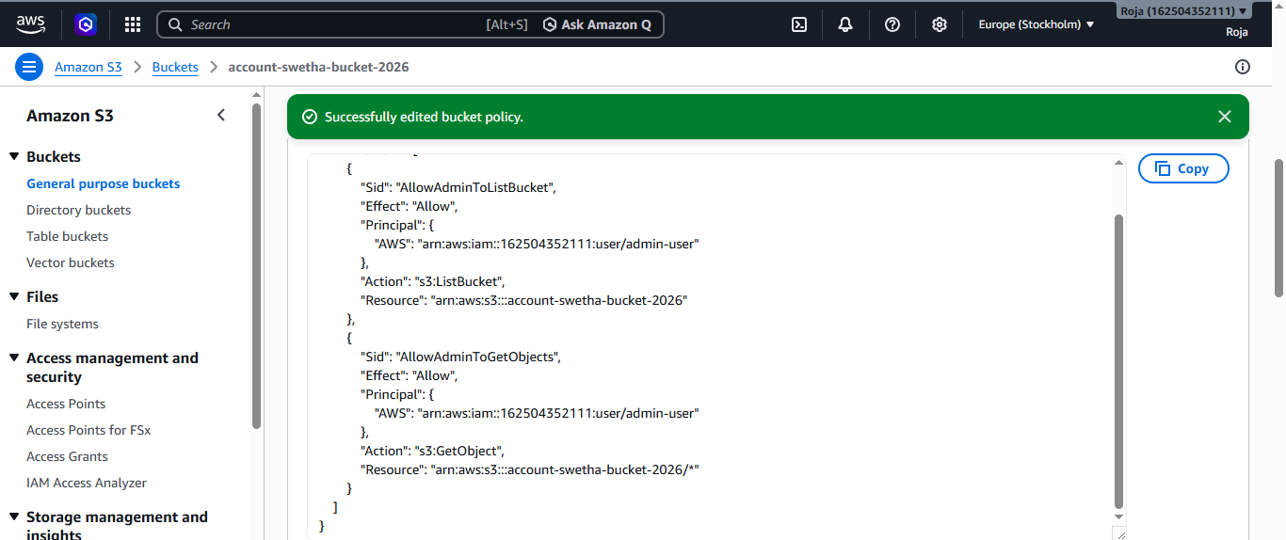

Step 4: Verify Access Using the Admin User
- Sign out of the current AWS account.
- Sign in using the Admin IAM user.
- Open the Amazon S3 service.
- Open the configured bucket.
- Verify that the uploaded objects are visible and can be downloaded.
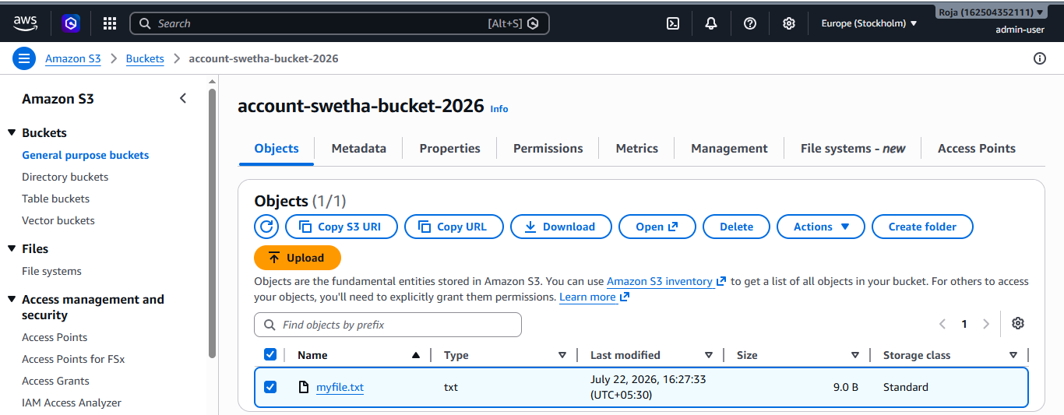

Task: 5.Set up lifecycle policies to automatically transition or delete objects based on specific criteria.

Objective:
To configure an Amazon S3 Lifecycle policy that automatically transitions objects to a different storage class or deletes them after a specified period.

Prerequisites
- AWS account with an IAM user having AmazonS3FullAccess or equivalent permissions.
- AWS Management Console access.
- An existing Amazon S3 bucket.
- At least one object uploaded to the S3 bucket.

Step 1: Open the Amazon S3 Service
- In the AWS Console search bar, type S3.
- Click Amazon S3 from the list of services.
- The Amazon S3 dashboard will open.
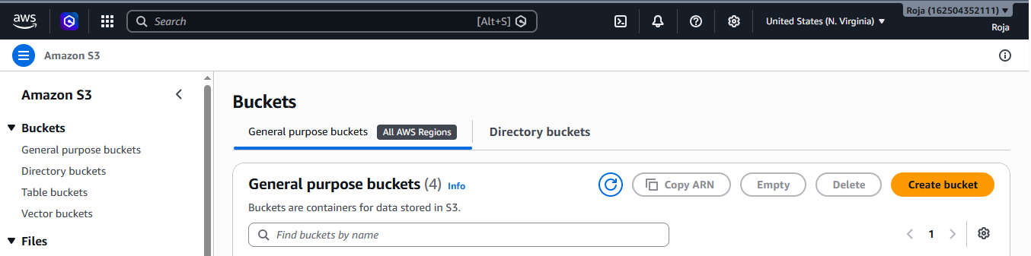

Step 2: Create an S3 Bucket
Upload Objects to the Bucket
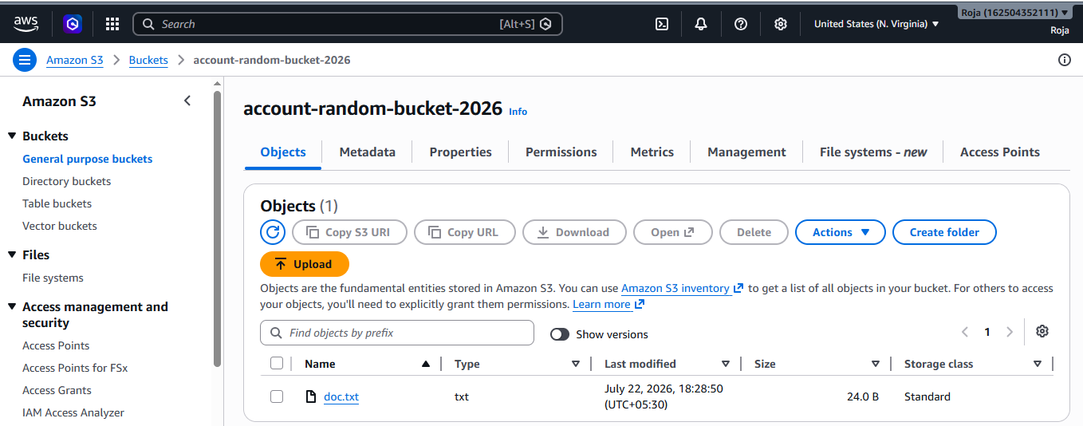

Step 3: Open the Lifecycle Rules Section
- Open the S3 bucket.
- Select the Management tab.
- Scroll to Lifecycle rules.
- Click Create lifecycle rule.

Step 4: Configure the Lifecycle Rule
- Enter a rule name.
  - Example:
Lifecycle-Policy
- Under Choose a rule scope, select:
  - Apply to all objects in the bucket
- Acknowledge the warning if prompted.
- Click Next or continue to the lifecycle actions section.

Step 5: Configure Transition Action
- Under Lifecycle rule actions, select:
  - Transition current versions of objects between storage classes
- Choose the destination storage class.
  - Example:
S3 Standard-IA
- Specify the transition time.
  - Example:
30 days after object creation

Step 6: Configure Expiration (Delete Objects)
- Select:
  - Expire current versions of objects
- Enter the expiration period.
  - Example:
90 days after object creation
3. Review and create rule.
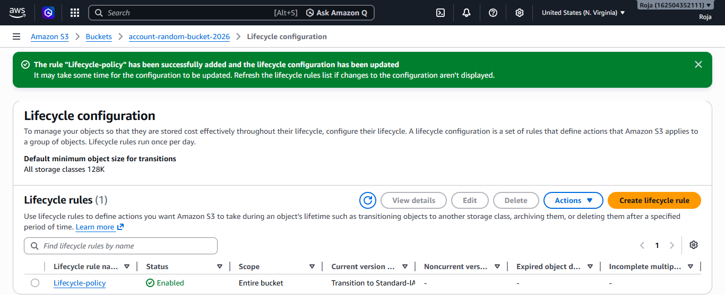

Step 7: Verify the Lifecycle Rule
- Open the Management tab of the bucket.
- Confirm that the newly created lifecycle rule is listed.
- Review the rule details to ensure the transition and expiration settings are correct.
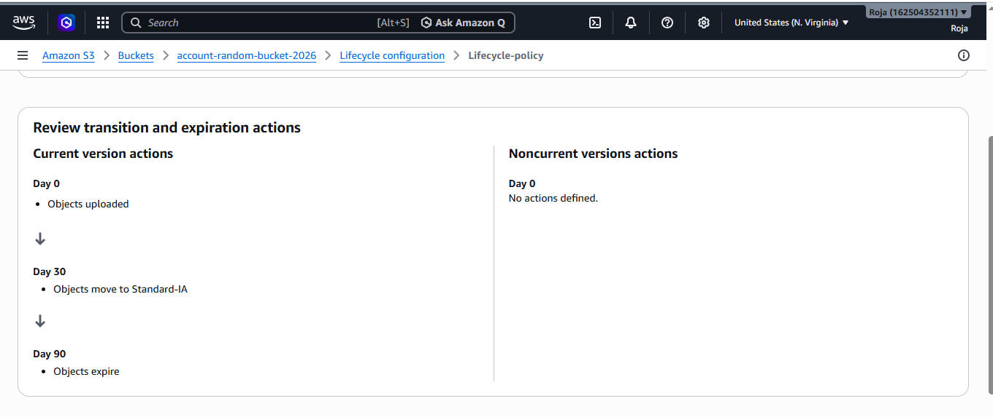
Task: 6. Push some objects to S3 using the AWS CLI.
Objective:
To upload files (objects) from a local system to an Amazon S3 bucket using the AWS Command Line Interface (AWS CLI).

Prerequisites
- AWS account with an IAM user having AmazonS3FullAccess or equivalent permissions.
- AWS CLI installed on the local system.
- AWS CLI configured with valid credentials using aws configure.
- An existing Amazon S3 bucket.
- One or more files available on the local system for upload.

Step 1: Verify AWS CLI Installation
- Open the terminal or command prompt.
- Check the installed AWS CLI version by running:
aws –version and Configure AWS CLI

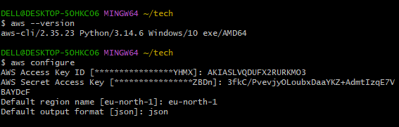

Step 2: Verify the S3 Bucket and Create Sample Files
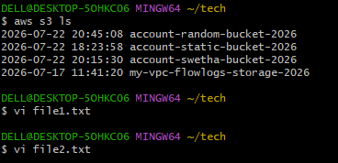

Upload a Single File to the S3 Bucket, Verify Uploaded Objects and Download an Object
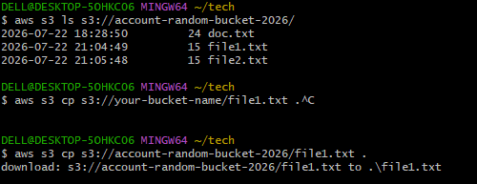

Task: 7. Write a Bash script to create an S3 bucket.

Objective:
To write and execute a Bash script that creates an Amazon S3 bucket using the AWS Command Line Interface (AWS CLI).

Prerequisites
- AWS account with an IAM user having AmazonS3FullAccess or equivalent permissions.
- AWS CLI installed on the local system.
- AWS CLI configured using aws configure.
- Bash shell (Linux, macOS, Ubuntu, or Git Bash on Windows).
- Internet connection.
Step 1: Verify AWS CLI Installation and Configure AWS CLI
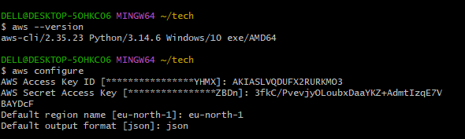

Step 2: Create a Bash Script and content to the script
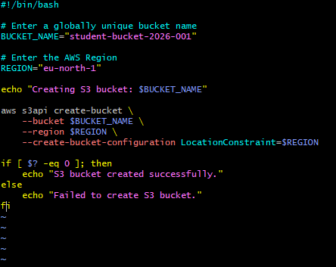

Step 3: Provide Execute Permission, execute the Bash Script and Verify the Bucket
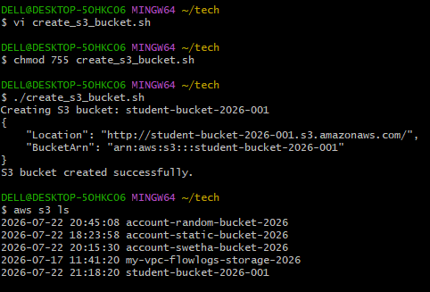
Step 4: Verify in AWS Management Console

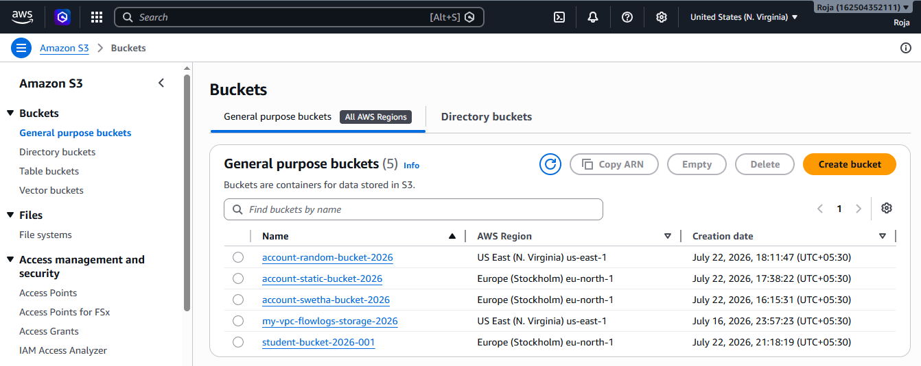

Task: 8. Upload a 1 GB file to S3 using the CLI.

Objective:
To create a 1 GB file on the local system and upload it to an Amazon S3 bucket using the AWS Command Line Interface (AWS CLI).

Prerequisites
- AWS account with an IAM user having AmazonS3FullAccess or equivalent permissions.
- AWS CLI installed on the local system.
- AWS CLI configured using aws configure.
- An existing Amazon S3 bucket.
- Bash shell (Linux, macOS, Ubuntu, or Git Bash on Windows).
- Sufficient local disk space (at least 1 GB).
Step 1: Verify AWS CLI Installation and Configure AWS CLI
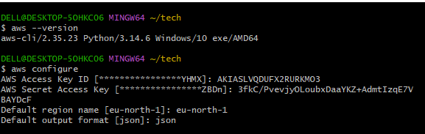

Step 2 : Verify the S3 Bucket
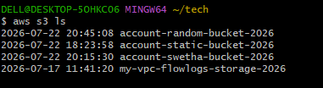

Step 3: Create a 1 GB File

For Linux/Ubuntu/macOS

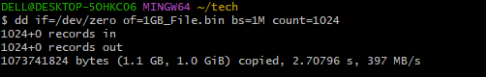

Step 4: Verify the File Size and Upload the File to Amazon S3
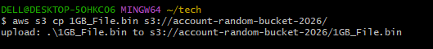

Step 5: Verify the Uploaded Object
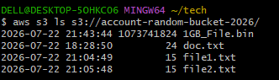
Step 6: Verify in AWS Management Console
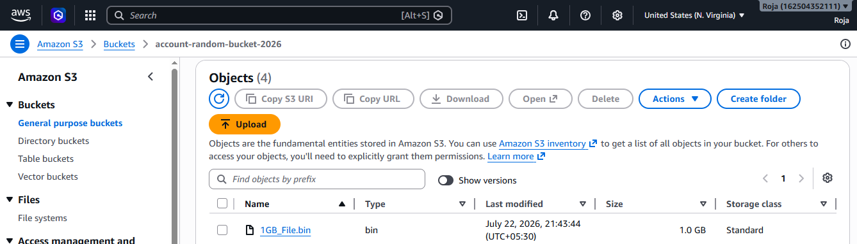

Step 7: Download the File
